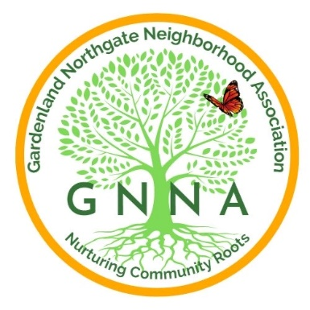
Gardenland Northgate Neighborhood Association (GNNA)
SCHOLARSHIP APPLICATION
2023/24

The Gardenland/Northgate Neighborhood Association (GNNA) is a community based 501 (c) (3) organization that seeks to improve the quality and safety of our community. Each year, GNNA provides scholarships to graduating seniors that live within the boundaries of the Gardenland Northgate Neighborhood Association. Scholarships are also offered to current college student who care continuing their education and live within the boundaries of GNNA. Priority will be given to first time applicants.

We encourage you to apply to one of our scholarships to provide financial support as you pursue your education at a community college, technical school, or a 4-year university. GNNA will be awarding $1000 scholarships for GNNA regular scholarships and a $1250 Josi Juarez Memorial scholarship.

Applications may be obtained from your career center, your school counselor or online through the GNNA webpage at www.GNNA.info or at the GNNA Facebook page at Gardenland/Northgate Neighborhood Association.

Scholarships will be given to awardees at the June 13, 2023, as part of a GNNA community meeting. We encourage awardees to invite their families to share in this joyous event.

ELIGIBILITY REQUIREMENTS:
- You must be a current high school senior, or its equivalent, with a graduation date in the 2023/24 academic year or a current college student who is continuing their education and meets the rest of the requirements.
- You must have enrolled in a community college, technical school, or a 4-year university and provide proof of registration or acceptance.
- You must live within the boundaries of the Gardenland/Northgate Neighborhood Association as defined on page 5 of this application. Eligibility is based on neighborhood residency and not which school you attend. Living outside the boundaries will disqualify you for consideration.
- You must be in good academic standing and provide your school transcript.

- Two Letters of Recommendations from a teacher, counselor, principal or a community leader or community organization.
SELECTION CRITERIA FOR THE GENERAL GNNA SCHOLARSHIP
- Meeting the above eligibility requirements.
- Essay response to the attached questions.
- 2.5 GPA minimum requirement
- Community Service and/or civic engagement
- School-Related Extracurricular Activities

CRITERIA FOR THE JOSI JUAREZ MEMORIAL SCHOLARSHIP

Josi Juarez was a long-time resident of Gardenland/Northgate and member of GNNA for many years. Josie made sure that GNNA gave a voice to the community. Josi was passionate about our community and emphasized the importance of community involvement.
In honor of Josi’s commitment to public service and our community, GNNA offers a special scholarship to applicants who demonstrate commitment to community service. The criteria are the same as the GNNA scholarship; however, special consideration will be given to applicants who demonstrate an exemplary commitment to community service. When applying, please indicate your interest in being considered for the Josi Juarez Memorial Scholarship.

SCHOLARSHIP APPLICATION

APPLICANT:

Name Today’s Date

Home Address (Number, Street, City, Zip Code)

Cell Phone Number E-Mail Address

SCHOOL INFORMATION:

Name of School Currently Attending Graduation Date

School Address (Number, Street, City, Zip Code)

Please respond to each of the following statements. Please keep your responses to a maximum of 350 words per question.

- Describe your short and long-term educational goals and your aspirational goals.

- Describe your community service and/or civil engagement.

- Tell us what you see as the positive attributes of our community.
The challenges this community faces and one thing you would like to see changed.

Please initial next to the items that pertain to you:

_______I understand I may be asked to participate in a personal interview with the Selection Committee.

_______I authorize Gardenland/Northgate Neighborhood Association to utilize information on my application and any photos for publicity or public relations purposes.

_____ I am interested in applying for the Josi Juarez Memorial Scholarship.

I certify all the information in this application is true to the best of my knowledge.

________________________________ _______________
Applicant (Print Name) Date

________________________________
Applicant’s Signature

Include the following items in your application
A valid copy of your current academic transcript.
Proof of acceptance or registration at an accredited university or community college.
2 Letter(s) of recommendations.
Proof of community involvement and/or civic engagement

Scholarship applications must be dropped off or mailed to GNNA c/o Stanford Settlement,
450 West El Camino Avenue, Sacramento, CA 95833 no later than Friday, May 17, 2024

If you have questions, please contact:
GNNABoard@gmail.com

GNNA BOUNDARIES

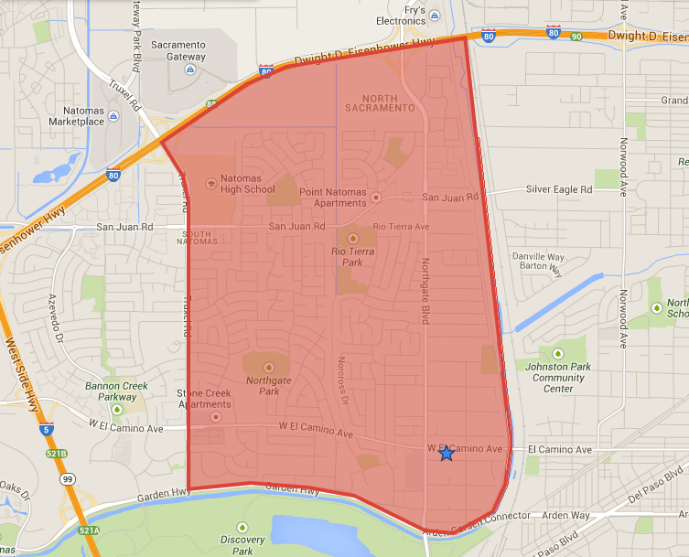

North: CA Interstate 80
East: Steelhead Creek
South: Garden Highway
West: East Side of Truxel Road

