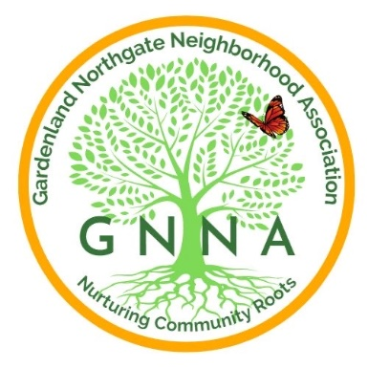
Gardenland Northgate Neighborhood Association
SCHOLARSHIP APPLICATION
2026

The Gardenland/Northgate Neighborhood Association (GNNA) is a community-based 501(c)(3) organization that seeks to improve the quality and safety of our community. Each year, GNNA provides scholarships to graduating seniors and current college students who are continuing their education. All applicants must live within GNNA's boundaries (please see attached map on page 6). Priority will be given to first-time applicants.

We encourage you to apply for our scholarships, which will provide financial support as you pursue your education at a community college, technical school, or a four-year university. Scholarships will be awarded on June 18, 2026, by the GNNA Board Members.

Applications may be obtained from your career center school counselor online through the GNNA webpage at www.GNNA.info or the GNNA Facebook page at Gardenland/Northgate Neighborhood Association.

Applications are due by 5 p.m. on May 22, 2026.
We encourage awardees to invite their families to share in this joyous event.

All ELIGIBILITY REQUIREMENTS MUST BE MEANT:

- You must be a current high school senior with a graduation date in the 2025/26 academic year.
- You must have enrolled in a community college, vocational school, or a 4-year university and provide proof of registration or acceptance.
- You must live within the GNNA boundaries defined on page 6 of this application. Eligibility is based on neighborhood residency. Living outside the boundaries will disqualify you from consideration.
- You must be in good academic standing, maintaining a 2.50 Grade Point Average or higher, and provide your school transcripts.

- Two current Letters of Recommendation from a teacher, counselor, principal, community leader, or community organization.

- Submit a completed essay that explicitly quantifies your community service, including total hours performed and years of involvement. Providing this information is required and will significantly impact scoring.

Please respond to each of the following statements. Your essay for question 6 should be a maximum of 350 words.

- Describe your short and long-term educational goals and your aspirational goals.
- Describe your community service and/or civic engagement and why you were inspired to participate in this endeavor.
- Describe the strengths and positive qualities of our community. In your opinion, what are the challenges it faces, and what is one change the community should advocate for?

CRITERIA FOR THE GILBERTO AND LUCY RAMIREZ MEMORIAL SCHOLARSHIP

The Gilberto and Lucy Ramirez Memorial Scholarship honors two dedicated community leaders whose service transformed the Gardenland-Northgate neighborhoods. Gilberto and Lucy founded GNNA, with Gilberto serving as president for 10 years. They each played key roles in the Stanford Settlement Board and Teen Center Committee. Gilberto was recognized for his community service and named the 2010 Natomas Man of the Year.
In honor of Gilberto and Lucy’s commitment to public service and our community, GNNA offers a special scholarship to applicants who demonstrate exemplary community service. The criteria are the same as for the GNNA scholarship; however, applicants must meet all eligibility requirements and demonstrate community involvement. When applying, please indicate your interest in being considered for the Gilberto and Lucy Ramirez Memorial Scholarship.
Applicants who wish to be considered for this scholarship must check the box below indicating their interest and respond to the prompt that follows.
☐ I would like to be considered for the Gilberto and Lucy Ramirez Memorial Scholarship.
Please share how you have contributed to strengthening the Gardenland-Northgate community through leadership, service, or advocacy. Describe specific ways you have demonstrated a commitment to helping others and building a stronger community. Additionally, explain how you hope to continue serving and make a positive impact in the Gardenland-Northgate community in the future.

SCHOLARSHIP APPLICATION

APPLICANT:

Name: ____________________________________________ Today’s Date: ________________
(First) (Last)
Home Address (Number, Street, City, Zip Code):
____________________________________________________________________________________

Cell Phone Number: _______________________ E-Mail Address: ____________________

SCHOOL INFORMATION:

Name of School Currently Attending: _______________________________________________

Graduation date: __________________
Proof of registration or acceptance:
Community college, vocational school, or a 4-year university Address (Number, Street, City, Zip Code): ___________________________________________________________________________________

Scholarship Recipient Participation
- As part of celebrating and strengthening our GNNA community, scholarship recipients are asked to participate in at least one (1) GNNA-sponsored event following the award.
- These events give us an opportunity to recognize your achievement, connect you with neighbors who support you, and highlight the positive impact our students are making in the community. GNNA will coordinate and communicate the event details at a future date.
- Participation in these one events is part of the scholarship experience, and scholarship funds will be disbursed upon completion of this engagement.
- We look forward to celebrating with you and seeing you involved in the GNNA community!

Please initial next to the items that pertain to you:

_______I authorize GNNA to utilize information on my application and any photos for publicity or public relations purposes.

_____ I am interested in applying for the Gilberto and Lucy Ramirez Memorial Scholarship, and I have included my essay.

I certify that all the information in this application is true to the best of my knowledge.

________________________________ _______________
Applicant (Print Name) Date

________________________________
Applicant’s Signature

Include the following items in your application
A valid copy of your current academic transcript.
Proof of acceptance or registration at an accredited university or community college.
2 Letter(s) of recommendations.

Scholarship applications must be dropped off or mailed to GNNA c/o Stanford Settlement,
450 West El Camino Avenue, Sacramento, CA 95833, no later than 5 PM, May 16, 2026

If you have questions, please contact:
GNNABoard@gmail.com
Roberto Ramirez (916) 308-6463

GNNA BOUNDARIES

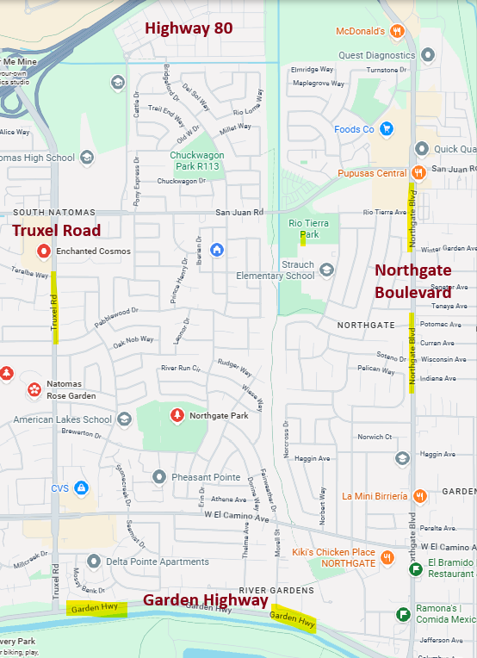

North: CA Interstate 80
East: Steelhead Creek
South: Garden Highway
West: East Side of Truxel Road

